**BuyBooks User Manual Report**

# Introduction

**Course Title**: Web Engineering

**Course Instructor:** Dr. Shuja-ur-Rehman Baig

**Student Name:** Mujaddad Ahmed

**Roll Number:** BSEF22M024

# Project Overview

BuyBooks is a full-stack book selling application developed using ASP.NET Core MVC (.NET 8). Designed to provide a platform for customers to buy their favorite books and novels.

**GitHub Url:** https://github.com/mujaddadahmed/se22-web-project-bsef22m024.git

# Core Functionalities and Technologies

1. **User Authentication:** 
   * Utilizes ASP.NET Core Identity for secure user registration and login.
   * Supports external authentication with Google and Facebook.
2. **Profile Management:** 
   * Users can update, edit, and remove their information in profiles.
   * Supports Email confirmation and password management.
3. **Search Functionality:** 
   * Built-in search feature using AJAX for asynchronous search results loading.
4. **Cart and Summary feature:** 
   * Supports Cart management and provides order summary before proceeding the order.
5. **Flexible payment methods:** 
   * Customers can pay from either card or cash apps.
   * Dummy payment services from stripe API are used.
6. **Order Status Listing:** 
   * Provides a detailed view of all the orders and their states i.e. approved/delivered/processed etc.

# Additional Enhancements

**AJAX:**

* Used for dynamic content loading, improving the user experience.

**Clean Architecture:**

* Applied to maintain a clean and manageable codebase.

**Caching:**

* Implemented to improve performance and speed up data retrieval.

**Dockerizing:**

* Dockerized the application for easier deployment in various environments.

## Technologies Used

* **Frontend:** HTML, CSS, JavaScript, AJAX, Bootstrap for responsive design.
* **Backend:** ASP.NET Core MVC
* **Database:** Microsoft SQL Server with Entity Framework Core as the ORM.
* **Auth:** ASP.NET Core Identity, Google authentication.
* **Deployment:** **Docker** for containerization and IIS local server.

## Screenshots

Figure 1: The First View of buybooks navigates the customer through the products we are offering.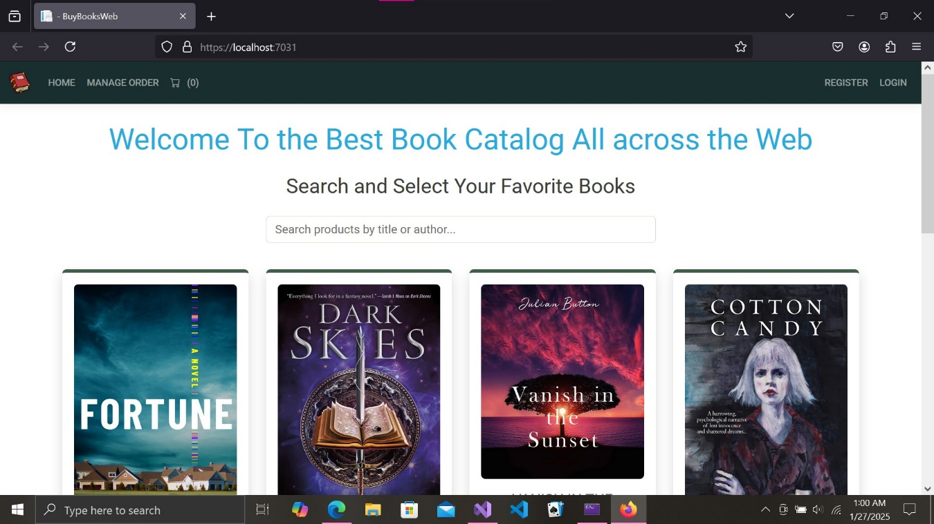

Figure 2: Search bar is provided for filtering search results on the basis of the search term. 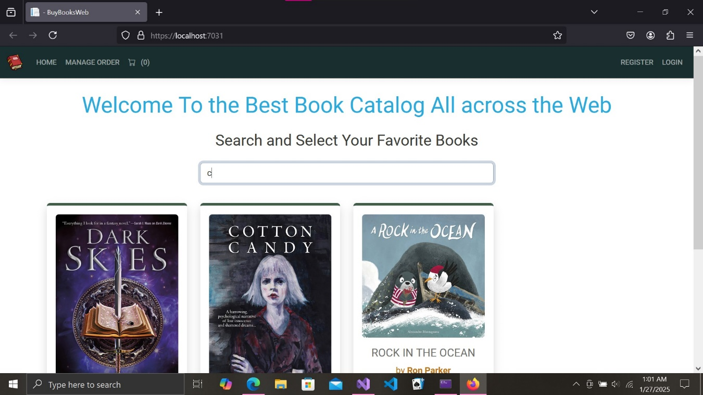

Figure 3: The Register page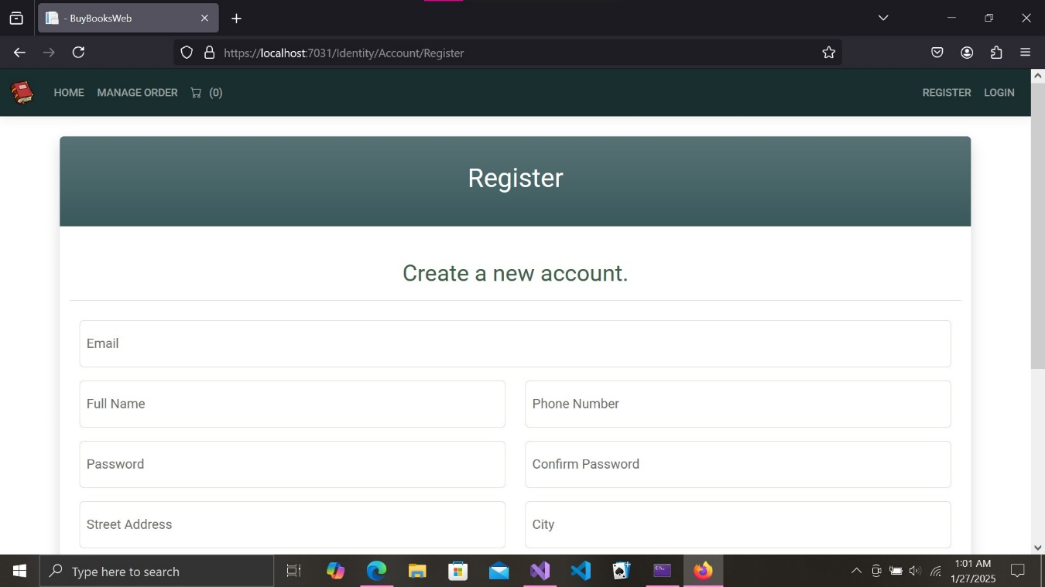

Figure 4: Populating all the required Fields.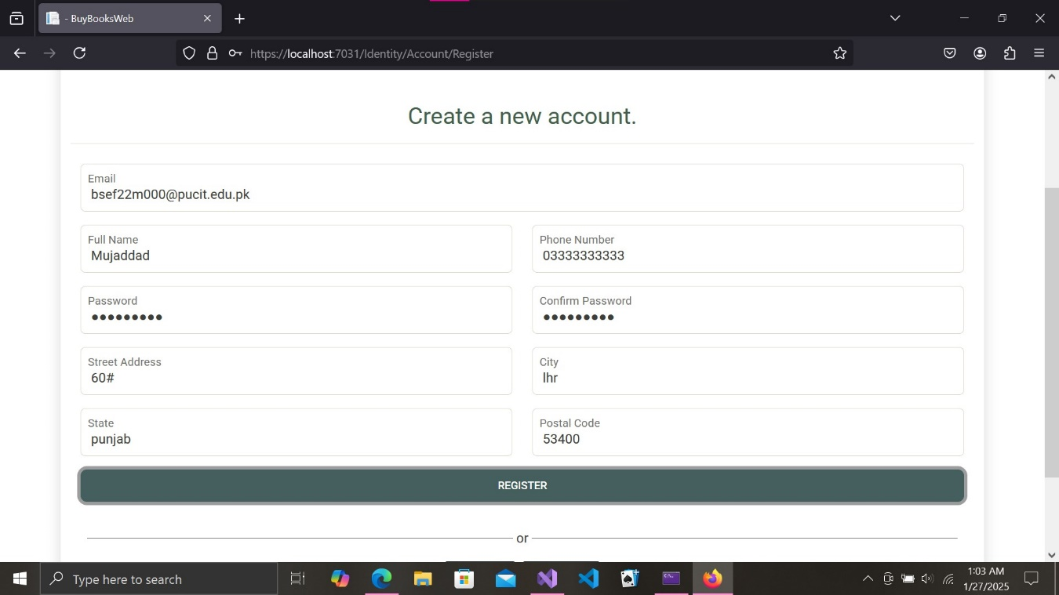

Figure 5: Registration Successfully done!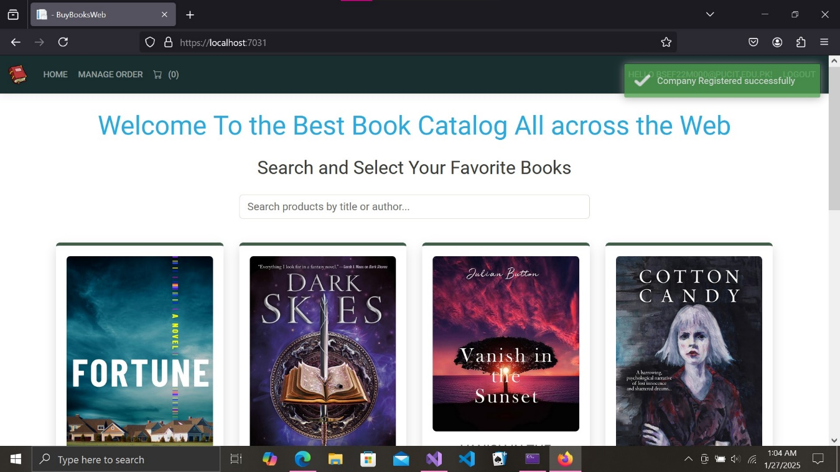

Figure 6: On clicking Hello<username>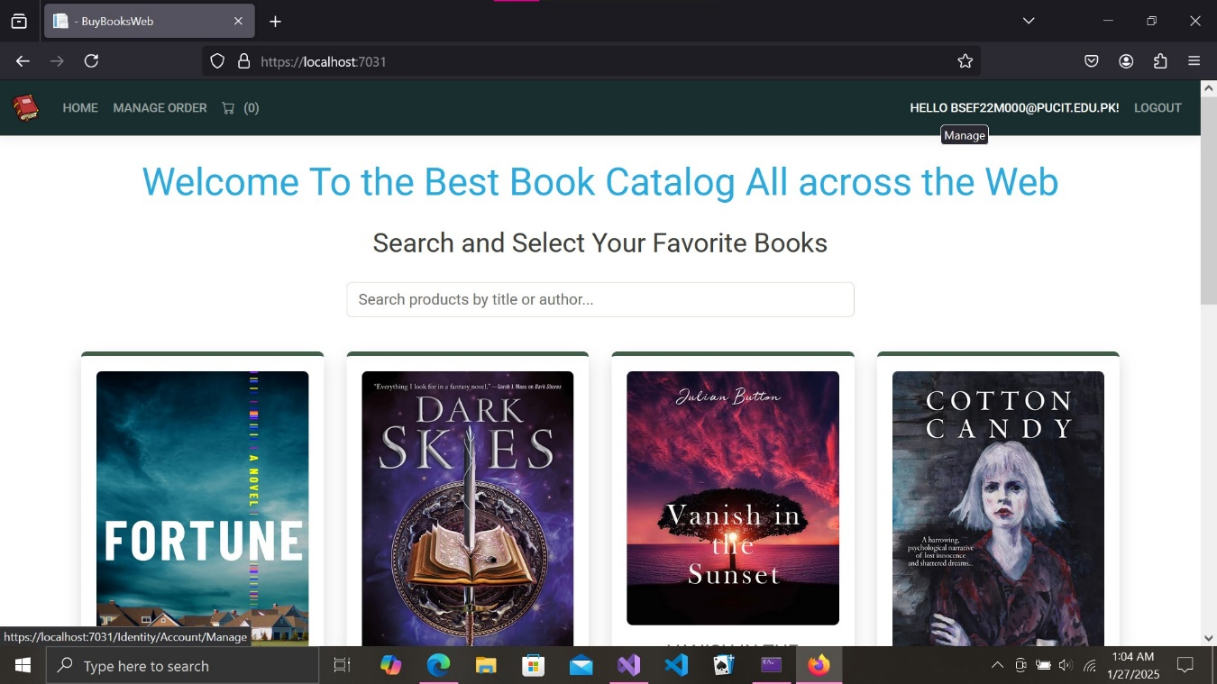

Figure 7: The Profile Options and information appear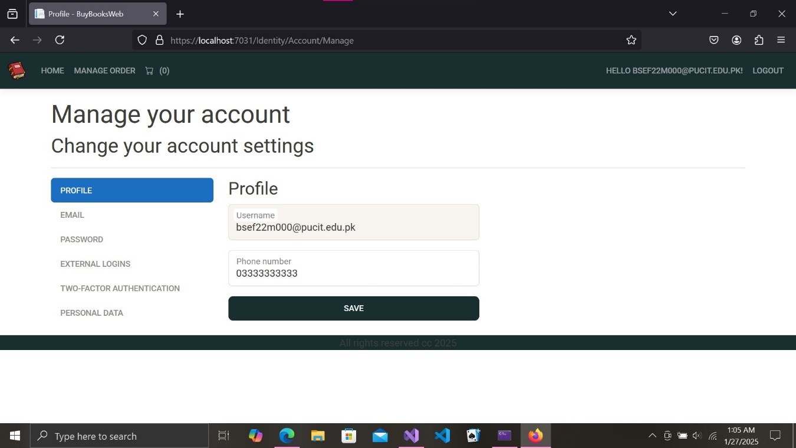

Figure 8: Email editing partial view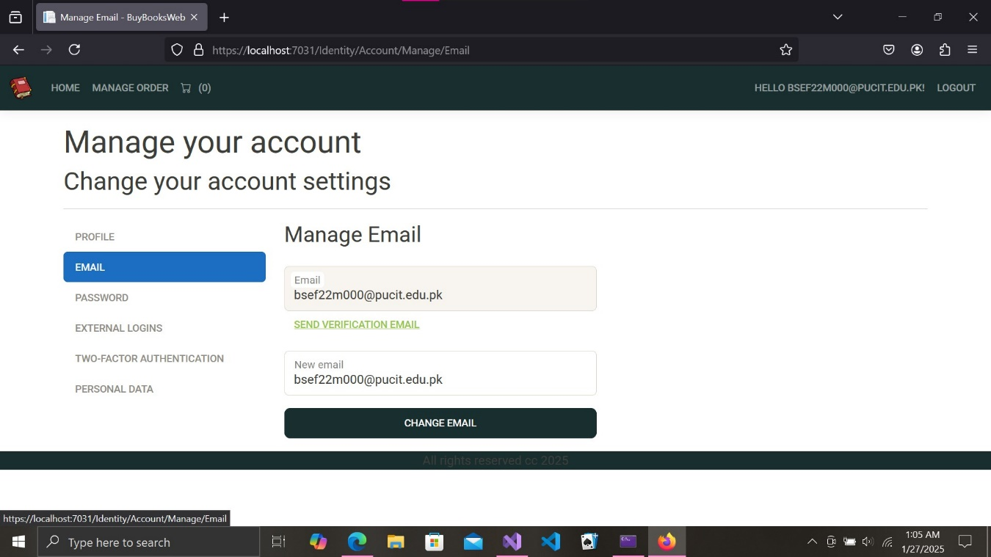

Figure 9: password changing tab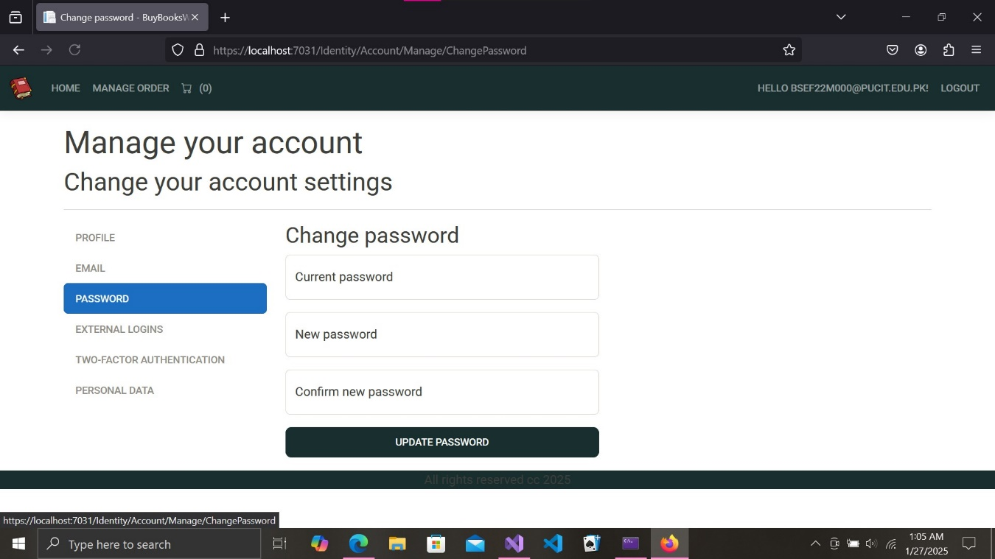

Figure 10: External login tab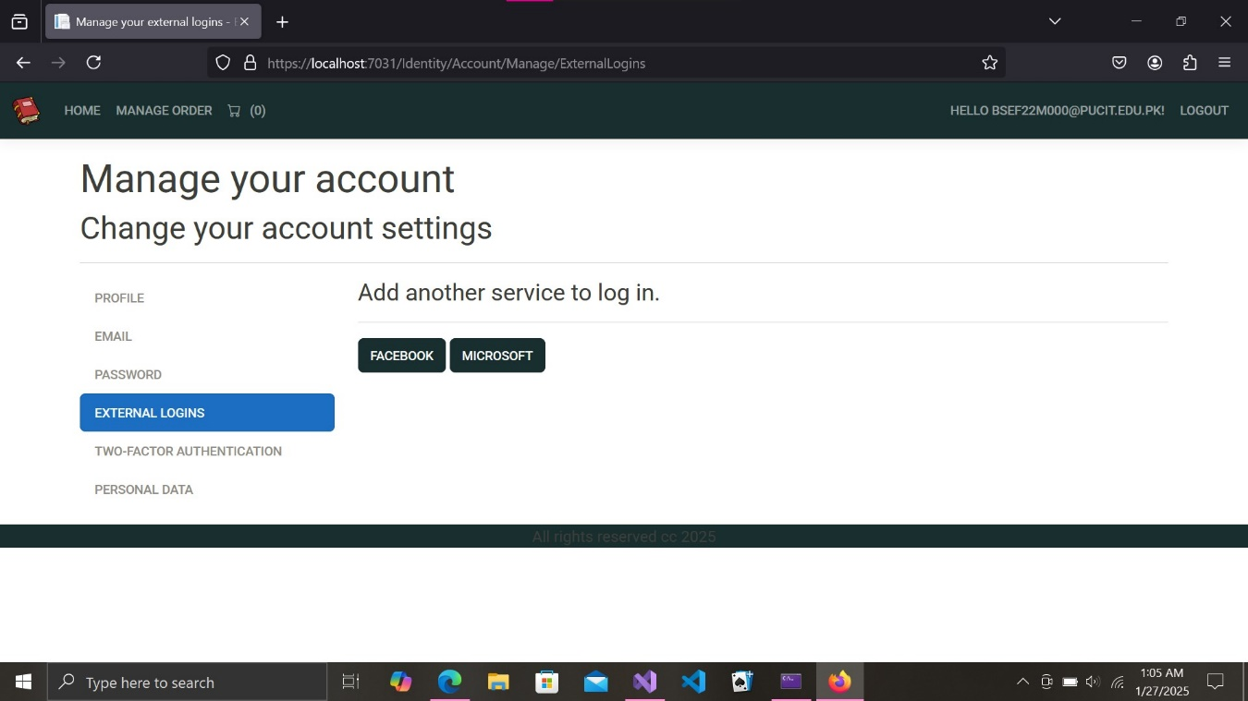

Figure 11: Personal data download and account deletion tab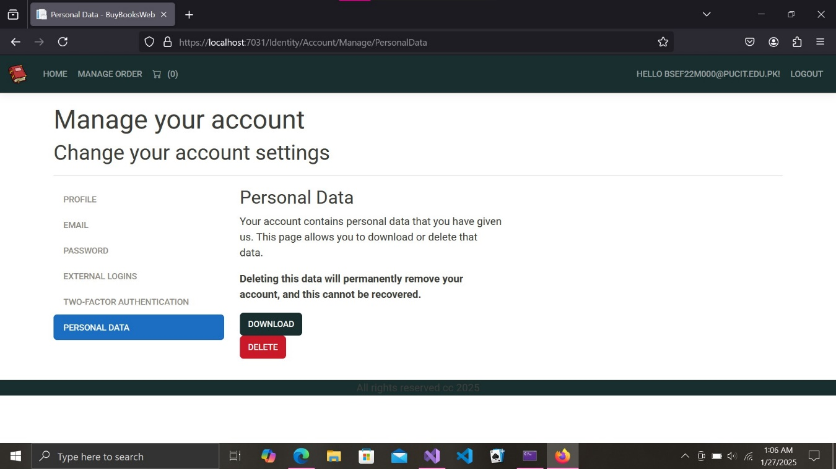

Figure 12: To add a product to cart click on details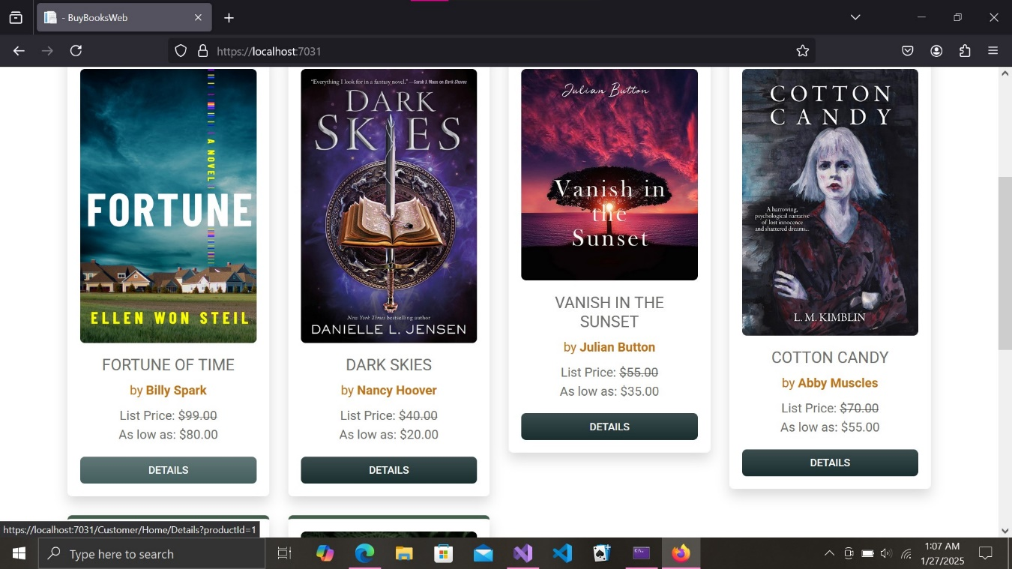

Figure 13:the details view appears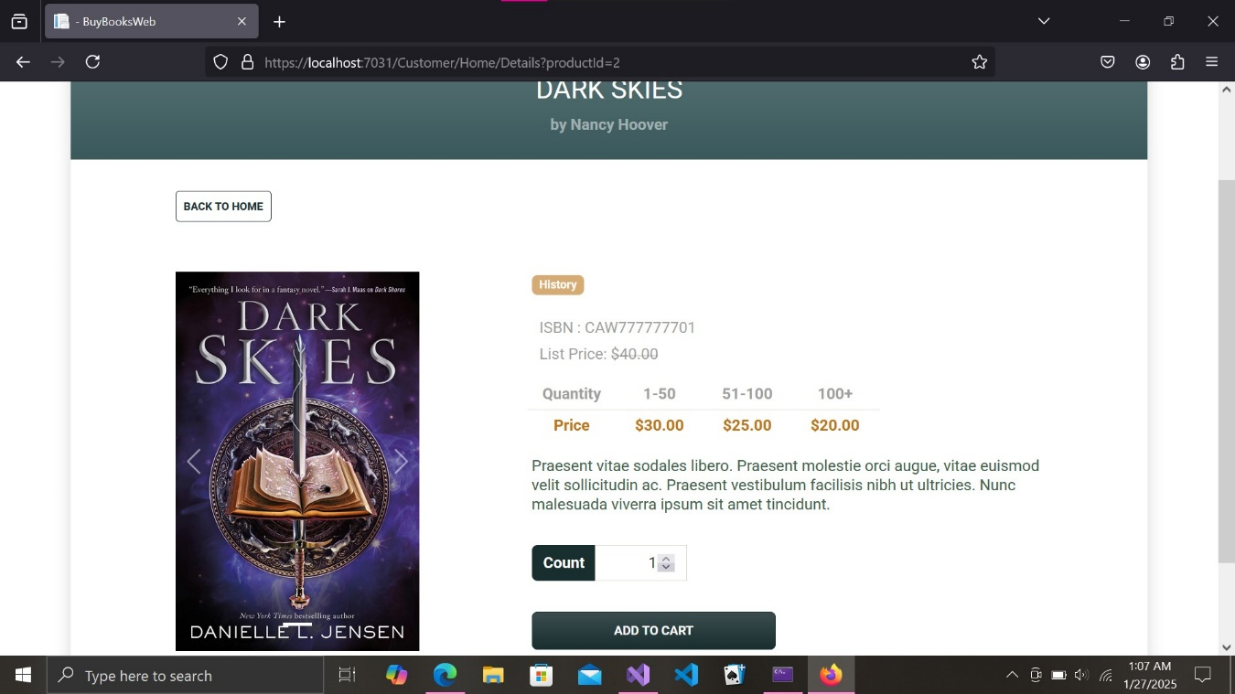

Figure 14: The count can be custom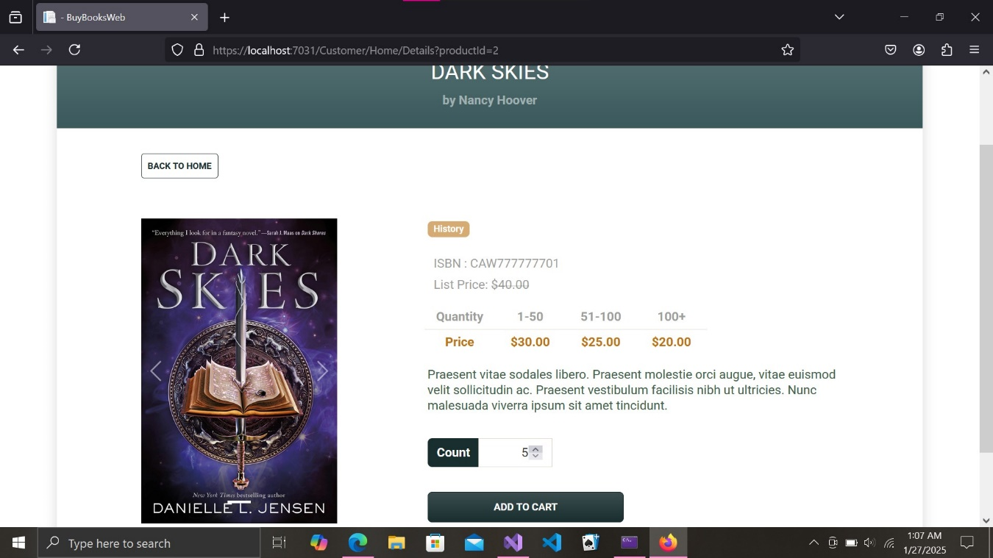

Figure 15: On clicking Add to cart the book is added to cart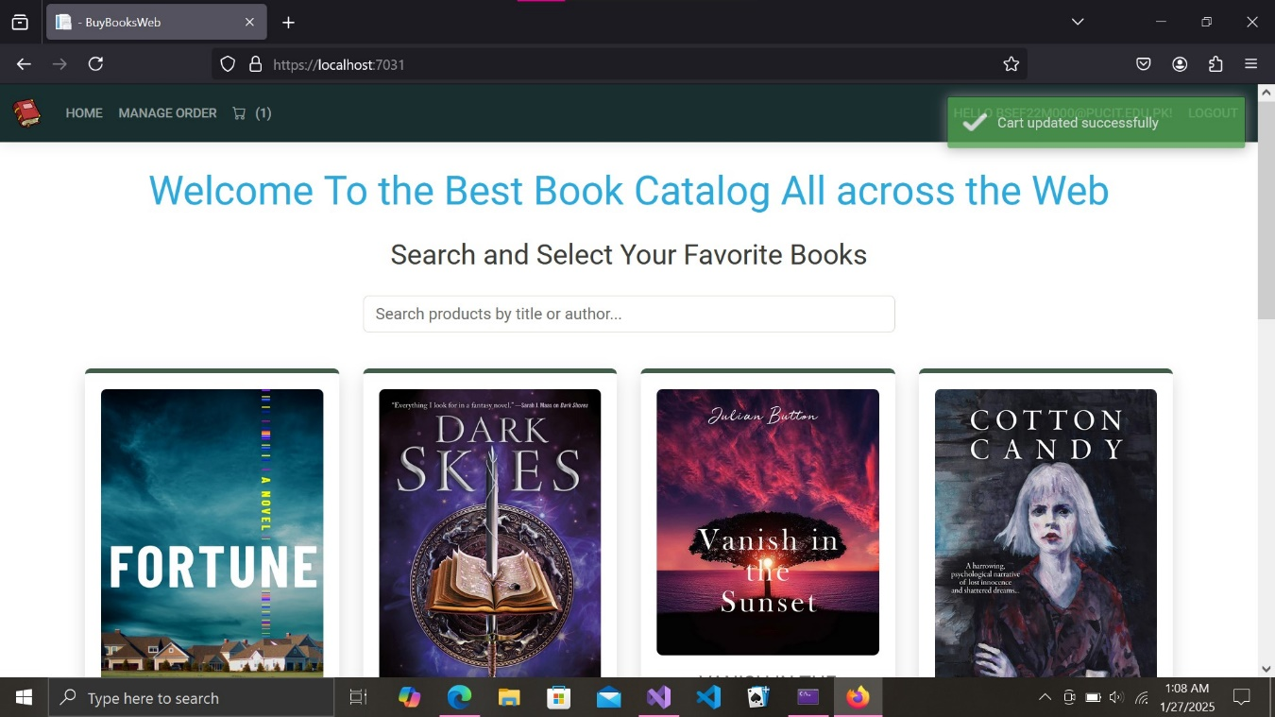

Figure 16: Click on the Cart Icon in top-left corner to view Cart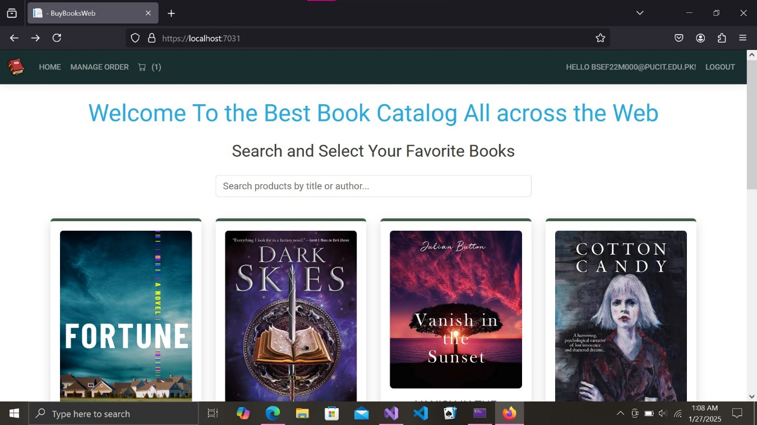

Figure 17: Products in cart appear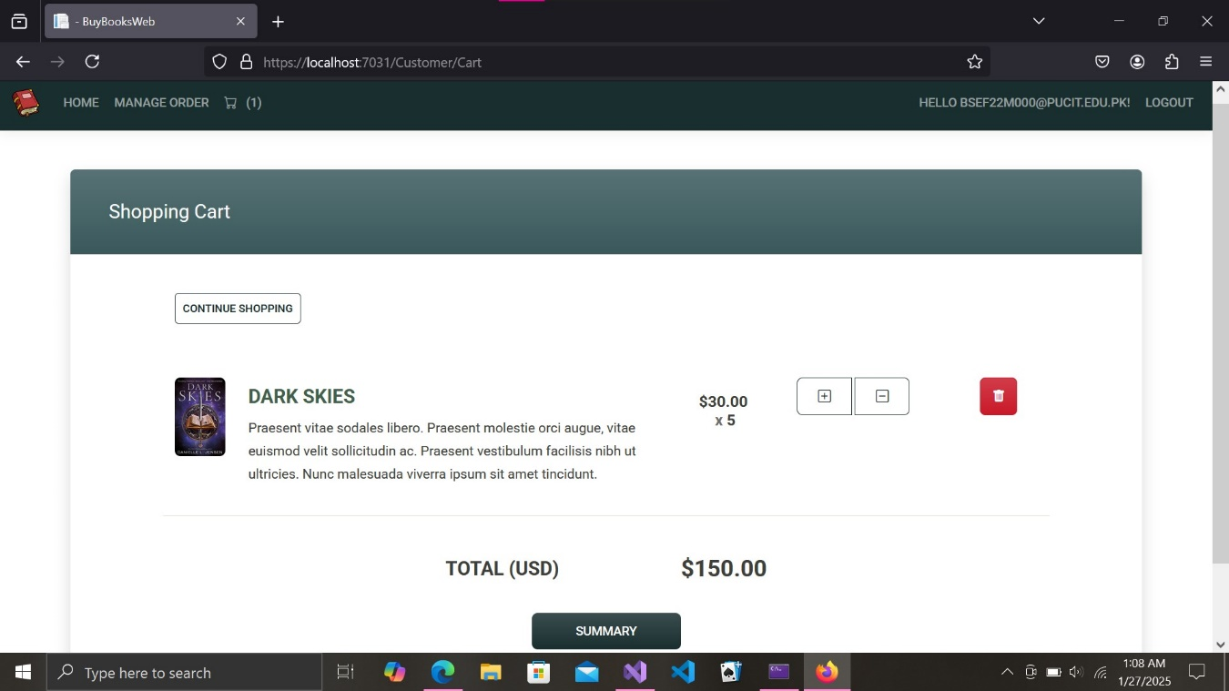

Fig18: The count can be increased or decreased here and also the product can be removed from the cart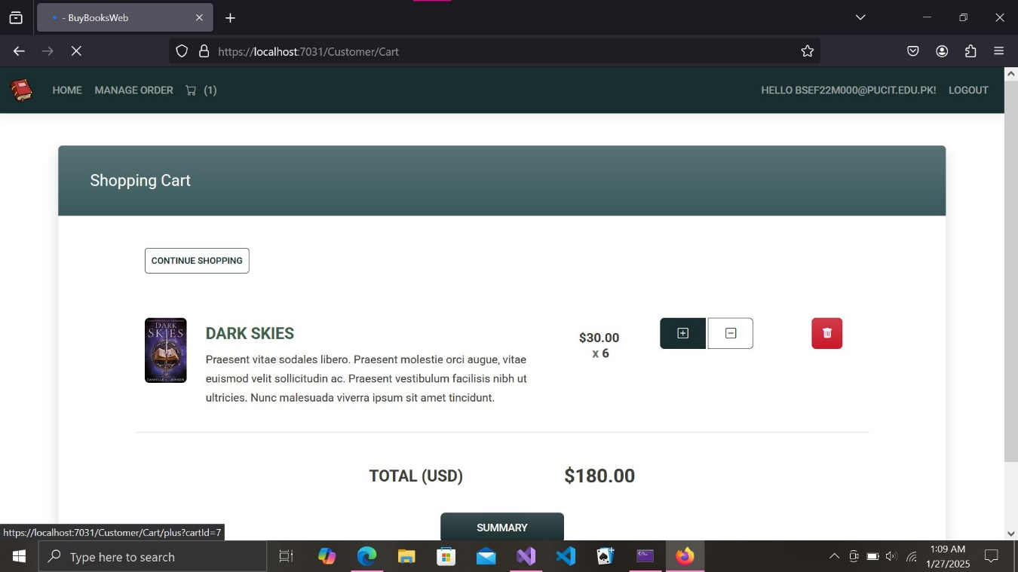

Figure19: On clicking the summary button the summary of our order appears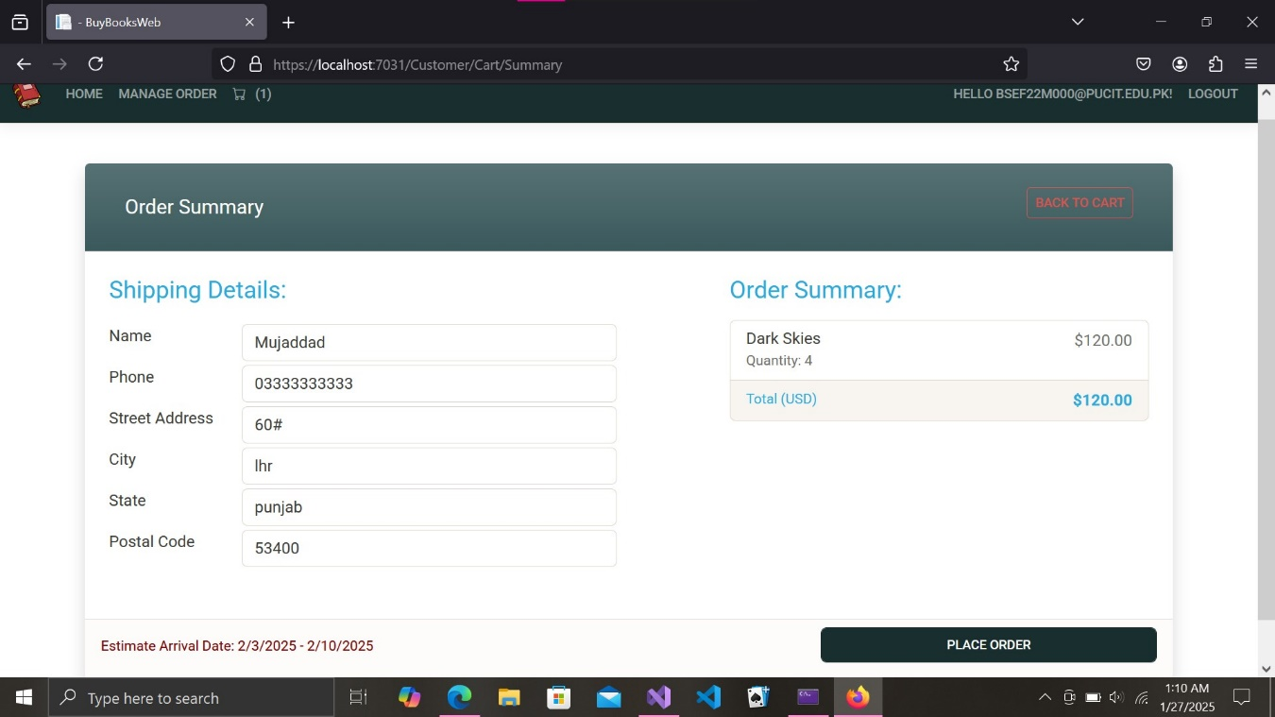

Fig20: On clicking place order in order summary, the payment view appears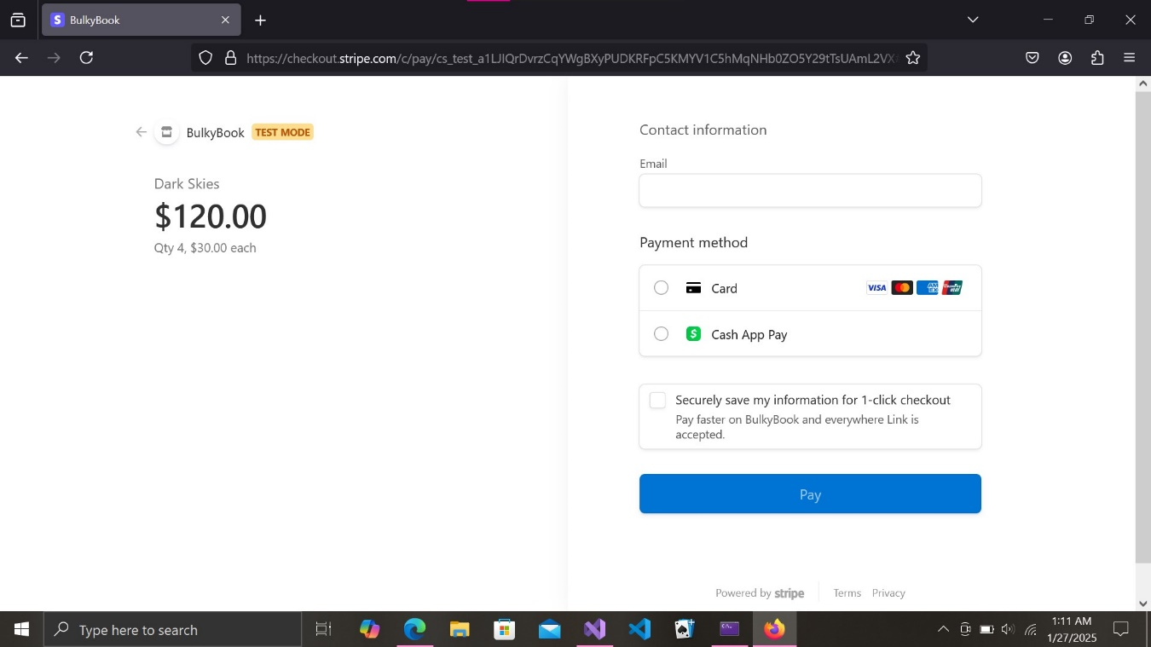

Fig21:Provide email and then choose payment option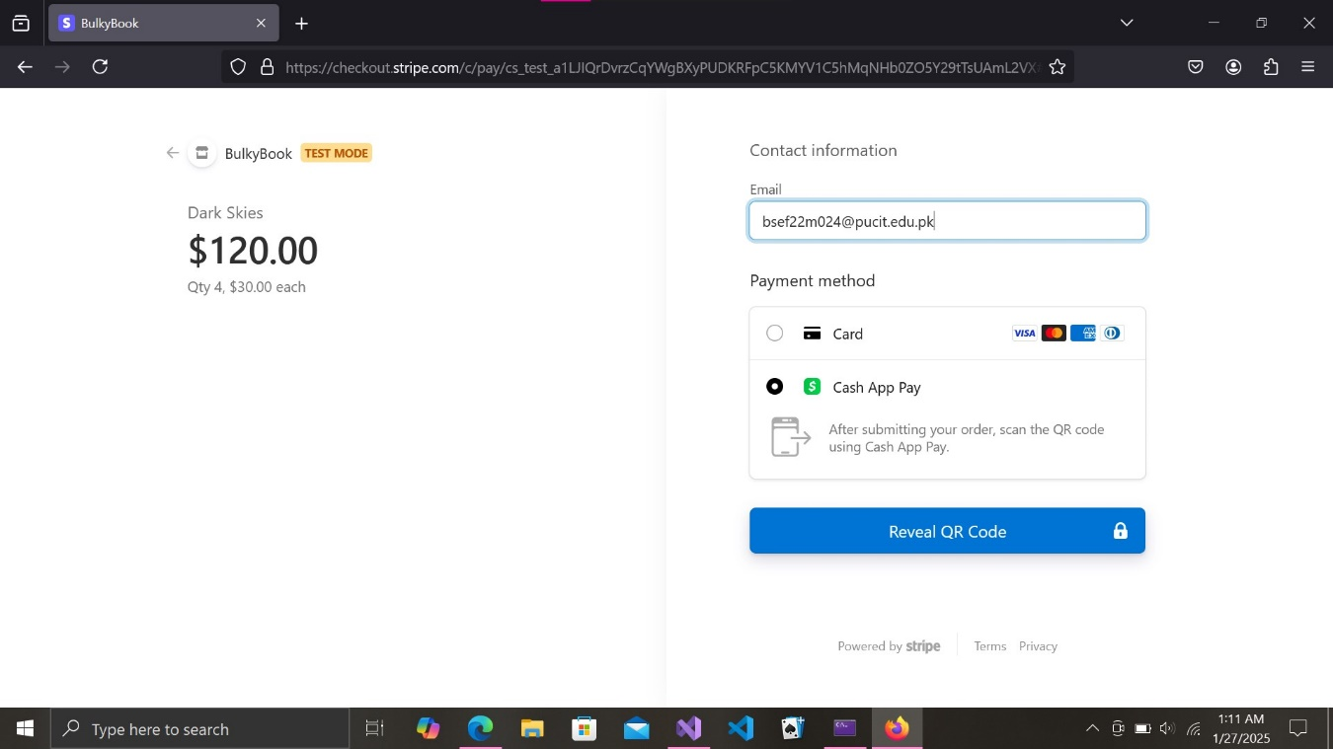

Fig22: A dummy QR appears which contains an option of simulate scan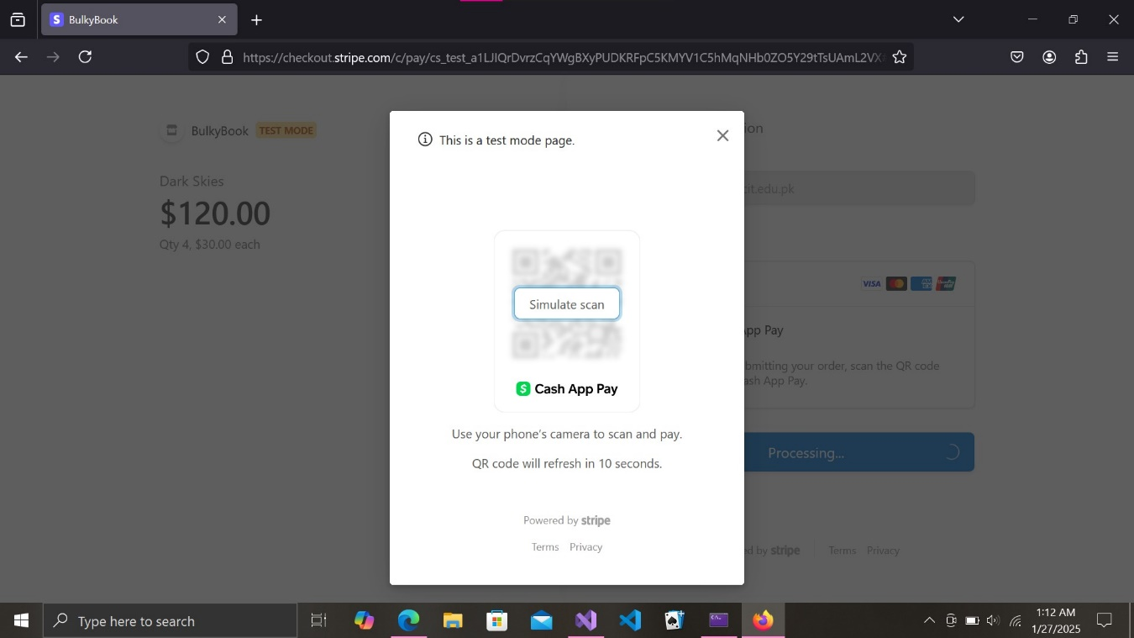

Fig23: the payment is authorized as it is a test payment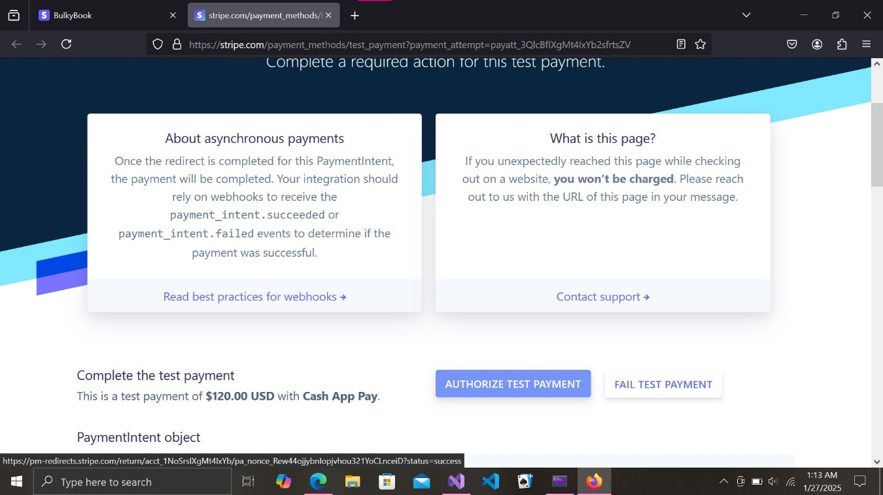

Fig 24: The Order is placed successfully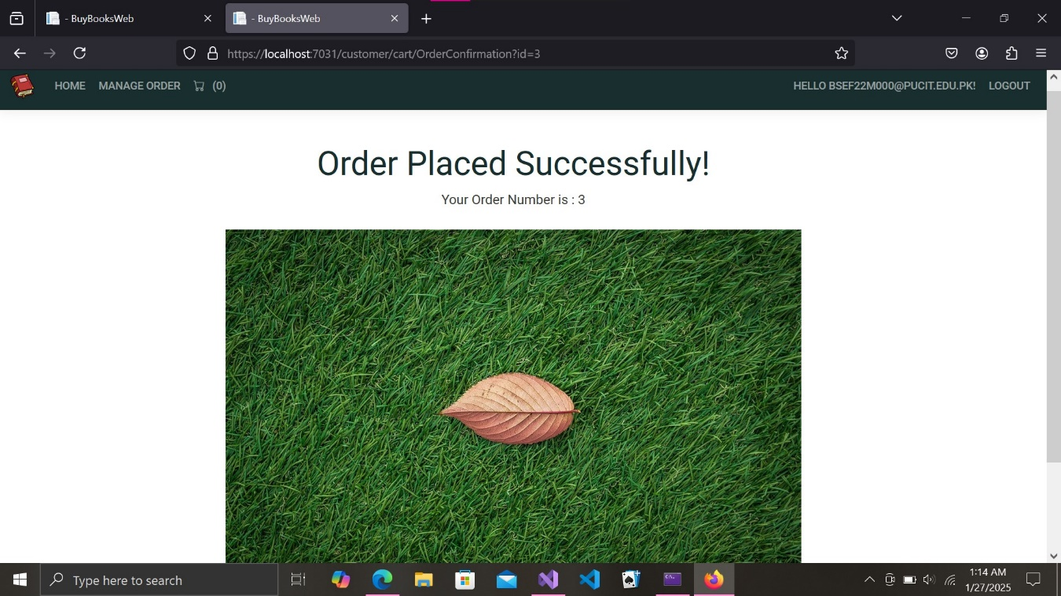

Fig25: The Order list can be accessed from the manage order option the top-left corner of home page and it contains the status of all your orders 